**7 kyu**

**Playing with Sets : Union**

1495% of48112[ZozoFouchtra](https://www.codewars.com/users/ZozoFouchtra)

JavaScript

* [TRAIN AGAIN](https://www.codewars.com/kata/playing-with-sets-union/train/javascript)
* [NEXT KATA](https://www.codewars.com/trainer/javascript)

Details

[Solutions](https://www.codewars.com/kata/playing-with-sets-union/solutions/javascript)

[Discourse (4)](https://www.codewars.com/kata/playing-with-sets-union/discuss/javascript)

* Add to Collection
* |
* Share this kata:

[Set](https://developer.mozilla.org/en-US/docs/Web/JavaScript/Reference/Global_Objects/Set) objects are new JavaScript built-in objects defined since [ECMAScript 2015](http://www.ecma-international.org/ecma-262/6.0/" \l "sec-set-objects." \t "_blank)

A **Set** lets you store unique values of any type. It comes with some useful methods like .add, .clear, .has . . . **BUT**some "Set operations" are missing, like . . .

**Union**

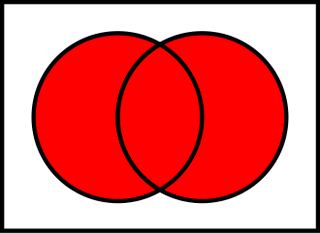

Two sets can be "added" together. The union of A and B, denoted by A ∪ B, is the set of all things that are members of either A or B.

**Examples:**

{1, 2} ∪ {1, 2} = {1, 2}.

{1, 2} ∪ {2, 3} = {1, 2, 3}.

{1, 2, 3} ∪ {3, 4, 5} = {1, 2, 3, 4, 5}

**Task**

Create function union getting 2 sets as arguments and returning a **new Set** as result of union of these 2 sets.

**Examples:**

A = new Set([1,2]);

B = new Set([2,3]);

C = union(A,B) // -> {1,2,3}

" May the Code be with you ! "

<https://www.codewars.com/kata/playing-with-sets-union/javascript>

1. **function** union(s1, s2){
2. *//...*
3. **const** s = **new** Set();
5. **for**(**const** item of s1) {
6. s.add(item);
7. }
8. **for**(**const** item of s2) {
9. s.add(item);
10. }
11. **return** s;
12. }
14. **var** res = union( **new** Set([2,2,2,2,2,2,2,2]), **new** Set( [2,2,2,2,2,2])  );


18. **for** (let item **in** res.values()) {
19. print(item + " ");
20. }